

Dharmsinh Desai University, Nadiad

Faculty of Technology, Department of Computer Engineering

B.Tech. CE Semester – V

Subject: (CE-515) Advanced Technologies

Project Title:

Personal Health Record System

[ PillPulse ]

By:

Shah Nidhi P. (roll no: CE125 id: 17CEUOS082)

Shah Vivek H. (roll no: CE126 id: 17CEUOG041)

Guided By:

Prof. Pinkal Chavda

Prof. Niyati Buch



Dharmsinh Desai University, Nadiad

Faculty of Technology, Department of Computer Engineering

**CERTIFICATE**

This is to certify that Advanced Technologies project entitled “Personal Health Record System” is the bonafied report of work carried out by

1. **Shah Nidhi P. ( 17CEUOF015)**

**2) Shah Vivek H. (17CEUOS079)**

Of Department of Computer Engineering, Semester V, academic year 2019-20, under our supervision and guidance.

|  |  |  |
| --- | --- | --- |
| Guide | Guide | HOD |
|  |  |  |
| **Prof. Pinkal Chavda** | **Prof. Parth Dave** | **Dr. C. K. Bhensdadia** |
| Assistant Professor of | Assistant Professor of | Head of the Department of |
| Department of Computer | Department of Computer | Department of Computer |
| Engineering, Dharmsinh Desai University, Nadiad. | Engineering, Dharmsinh Desai University, Nadiad. | Engineering, Dharmsinh Desai University, Nadiad. |

Table of Contents

1Abstract...…………………………..…………………..……………………………………..…42 Introduction……………………………………………………………………….….................5 2.1 Project Details: Brief Introduction …………………...............................................................5 2.2 Technology and Tools Used .....................................................................................................5 3 Software Requirement Specifications ………………………...……………………………...…7 3.1 Scope ………………………………………………………...………………………………..7 3.2 System Functional Requirements ……………….…………………………………………...7 3.3 Other Non‐Functional Requirements ……………….…………………………………….....13 4Design……………….……….……………………….……………………………..………….15 4.1 XML ………………………………………..…….……………………………..…………...15 4.2 DTD ………………………….………………………...….……………………..………….17 4.3 XSD ………………………..……………………………………………….………...……..18 4.4 XSLT……………………….…………………………………………………..……..……..18 4.5 DFD ……………………………………………………………………………..………..…24 4.6 E-R Diagram ………….………………………………………………..………………..…..25 4.6 data Dictionary……..…………………………………………………………………...…...26 5 Implementation Details ……………………………….……………………………….…...…33 5.1 Modules …………………………………..…………………………………………….…...34 5.2 Functional prototypes ……………………………………………………………………….34 6 Testing ………………………………………………………………………………………...36 6.1 Testing Method….………………………………….……………………………....……….36 6.4 Test Cases …………………………………………………………………………….....….36 7 Screen‐shots of the System …………………………………………………......……..……...38 8 Conclusion ……………………………………………………………………….…...……….50 9 Limitations and Future Extensions of System ……………………………………………...…51 10 Bibliography ……………………………………………………….……………………..….51

1. Abstract

A tour and travel website is a website on the internet that is dedicated to travel. The site may be focused on travel reviews, trip fares, or a combination of both. The purpose of website is established fact that Internet users are increasing today. One of the main purposes of the website is to facilitate the offline customer online because customers cannot spend their precious time in markets trying to find out the best deal. India is a country where in a few days holiday, you can enjoy a lot .The problem is that we although having many websites but they offer different kind of services .The customers are enjoying a lot but there is a lack of relationship between travel agency and customers and hence we are establishing that relationship by caring and serving all customers in the same manner that we wish to be served .We need to build a world class team armed with knowledge and backed by technology to advise customers in planning of their holidays. We will be putting an effort to provide the right choice to the people when they plan a holiday and beware them from the false advertising. We will provide them services which they need in duration of their holiday. In this website you can choose any package of tour and travel services and enjoy a lot. We provide best hotel for relaxation, best food and water for your health, best travel services, hot water and shower for your better refreshment.

2. Introduction

**2.1 Brief Introduction**

Traveland provides packages and services that are needed by customer. It saves your time for collection of holiday to manage your trip. We help customers to go travel right path for the destination and save a lot of time for its users by giving a facility of pre-defined packages with all services they need. We also provide facility of booking tickets. We also provide hotel booking facility.

You can explore the places inside and outside the country. India, one of the most beautiful locations of South Asia is also one the popular countries of the world. Therefore this tourist hub welcomes more than a 5 million foreign tourist from different location of the world. A trip to this beautiful country can reveal numerous mystic things regarding its culture, art, tradition, history etc. India has become a favored place of visit for travelers from all over the world. Each state of this wonderful country is unique when it comes to the scenic beauty, nature of the people living in the country and the hospitality of Indians. Also we provide facility of booking tickets and hotels to. You can also search for destinations, hotels and tickets separately.

**2.2 Tools/Technologies Used**

**Technologies:**

HTML 5

CSS 3

Bootstrap 4

Angular cli

Typescript

Node JS

Express JS

MongoDb

Railway-wrapper-api

**Tools**

Visual Studio Code

**Platforms**

localhost/4200 for Angular

localhost/8000 for Node js

mongodb://127.0.0.1:27017

3. Software Requirement Specifications

**3.1 Product Scope**

This system is designed to enable customers to book tour packages, hotels and tickets from anywhere anytime. It provides mailing system whenever user books hotel or tickets. It helps you searching destinations and hotels you want.

**3.2 Types of User**

1. Admin

2. Customer

3. Manager

**3.3 System Functional Requirements**

**R.1 Admin**

R.1.1 Manage Plans

Description: Admin will add, update and delete the plans.

R.1.1.1 Add Plans

Description: Admin will add the plan details.

Input: Details of plan

Output: Success message

R.1.1.2 Delete plan

Description: System will show all the plans and then admin will select the plan which she wants to delete.

R.1.1.2.1 View plans

Input: User selection

Output: list of existing plans

R.1.1.2.2 Confirm deletion

Input : User selection

Output: Success message

R.1.2 View feedback

Description: Admin can view the feedback

Input : User selection.

Output: list of feedbacks

**R.2 Customer**

R.2.1 Register customer

Description: Customer needs to register by providing details.

Input: Customer details.

Output: Success message.

R.2.2 Book tickets.

Description : If user doesn't select any plan and only wants to book tickets then he can only book the tickets.

R.2.2.1 Select Medium

Description: User will select the medium of travelling

Input: User selection.

Output: Booking prompt

R.2.2.2 Book the tickets

Description: User enters destination, source and date.

Input: trip details

Output: Payment gateway

R.2.3 Buy Plan

Description: Customer can view existing plans and book it.

R.2.3.1 Show Plan

Description: It will show all available plans.

Input: User selection.

Output: List of available plans.

R.2.3.2 Select a Plan

Description: It allows customer to select a plan.

Input: User selection.

Output: Payment Gateway.

R.2.3.3 Make Payment

Description: Customer will provide the bank details and pay for the trip

Input: Bank details.

Output: Confirmation message.

Process: Amount is transfer to agency's account.

R.2.4 Add Feedback

Description: User can give feedback of agency.

Input: Feedback.

Output: Success message.

R.2.5 Define Own Plan

Description : Customers will fill their own plan details in the form.

R.2.5.1 Opt for self defined plan

Description: If users want to plan their own trip then agency provides the facilities for this.

Input: User selection.

Output: Display the form

R.2.5.2 Provide the details

Description : Customer provides the destination, starting and ending date for trip.

Input: Plan details.

Output: Validation message

Process: Manager validates the plan and plans the trip and then sends the details of trip to the customer for confirmation.

**R.3 Manager**

Description: Agency manager will book the hotel, tickets and cab. Manager also views the customer list.

R.3.1 Book tickets and hotel.

Description: Agency manager will book the hotel as per the user selection plan.

R.3.1.1 Select Hotel

Description: Manager select hotel as per the plan and books the room.

Input: User selection.

Output: Details of Hotel.

R.3.1.2 Book Hotel

Description: Manager enters the check-in, check-out date and number of rooms.

Input: Booking details.

Output: Success message.

R.3.1.3 Select the option

Description: Manager selects the medium of travelling

Input: User selection.

Output: Booking dashboard.

R.3.1.4 Book the tickets

Description: Manager enters destination, source and date.

Input: trip details

Output: Payment gateway

R.3.2 View customer list

Description: Manager views customer details.

Input: User selection

Output: customer list

R.3.3 Interact with customer

Description : Manager will send the details of self defined plan to the customer.

Input: Details of plan.

Output: Confirmation

Process: Email will be sent to the customer.

R.3.4 Book Cab

Description: Manager enters destination, source and date.

Input: Destination

Output: Confirmation

**R.4 Login**

Description: Every User must login to access service.

Input: User name and password.

Output: Redirection to home page.

**R.5 Logout**

Description: User can log out after finishing booking.

Input: User selection.

Output: Redirection to Login page.

**R.6 Manage self profile**

Description : User will change the details.

Input: Enter details.

Output: Confirmation

**R.7 Make Payment**

Description: Manager or customer will provide the bank details and pay for the tickets

Input: Bank details.

Output: Confirmation message.

Process: Amount is transferred.

**3.4 Other Nonfunctional Requirements**

**1. Performance**

The system must be interactive and the delays involved must be less. So in every action-response of the system, there are no immediate delays. In case of opening App components, of popping error messages and saving the settings or sessions there is delay much below 3 seconds.

**2. Safety**

User details should be securely stored to the server. The main security concern is for user account hence proper login mechanism should be used to avoid hacking.

**3. Reliability**

As the system provides the right tools for discussion, problem solving it must be made sure that the system is reliable in its operations and for securing the sensitive details.

**4. Database**

System requires to access users data fast to maintain the performance.

4. Design

**4.1 XML**

<?xml version="1.0" encoding="utf-8"?>

<tickets xmlns:xsi="http://www.w3.org/2001/XMLSchema-instance">

<tickets>

<ticket id="T00001">

<c_id>C00001</c_id>

<destId>D00004</destId>

<tkttype>Plane</tkttype>

</ticket>

<ticket id="T00002">

<c_id>C00002</c_id>

<destId>D00002</destId>

<tkttype>Train</tkttype>

</ticket>

<ticket id="T00003">

<c_id>C00003</c_id>

<destId>D00002</destId>

<tkttype>Bus</tkttype>

</ticket>

<ticket id="T00004">

<c_id>C00004</c_id>

<destId>D00001</destId>

<tkttype>Train</tkttype>

</ticket>

<ticket id="T00005">

<c_id>C00005</c_id>

<destId>D00003</destId>

<tkttype>Plane</tkttype>

</ticket>

<ticket id="T00006">

<c_id>C00003</c_id>

<destId>D00006</destId>

<tkttype>Train</tkttype>

</ticket>

</tickets>

<?xml version="1.0" encoding="UTF-8"?>

<packages xmlns:xsi="http://www.w3.org/2001/XMLSchema-instance">

<package id="1">

<pkgname>Goa</pkgname>

<pkgcost>1000</pkgcost>

<noofdays>4</enddate>

<initdest>Surat</initdest>

<pkgdetails>Enjoy the package.</pkgdetails>

</package>

<package id="2">

<pkgname>Leh-Ladakh</pkgname>

<pkgcost>10000</pkgcost>

<noofdays>6</enddate>

<initdest>Ahmedabad</initdest>

<pkgdetails>Enjoy the package.</pkgdetails>

</package>

</packages>

**4.2 DTD**

<!DOCTYPE packages[

<!ELEMENT packages (package*)>

<!ELEMENT package (pkgname,pkgcost,stdate,enddate,initdest,pkgdetails)>

<!ELEMENT pkgname (#PCDATA)

<!ELEMENT noofdays (#PCDATA)>

<!ELEMENT initdest (#PCDATA)>

<!ELEMENT pkgdetails (#PCDATA)>

<!ATTLIST package pkgid ID #REQUIRED>

]>

**4.3 XSD**

<?xml version="1.0" encoding="utf-8"?>

<xs:schema attributeFormDefault="unqualified" elementFormDefault="qualified" xmlns:xs="http://www.w3.org/2001/XMLSchema">

<xs:element name="tickets">

<xs:complexType>

<xs:sequence>

<xs:element name="ticket" type="TicketType" minOccurs="0" maxOccurs="unbounded"/>

</xs:sequence>

</xs:complexType>

</xs:element>

<xs:complexType name="TicketType">

<xs:all>

<xs:element name="c_id" type="xs:string">

<xs:simpleType>

<xs:restriction base="xs:string">

<xs:pattern value="C[0-9][0-9][0-9][0-9][0-9]"/>

</xs:restriction>

</xs:simpleType>

</xs:element>

<xs:element name="destId" type="xs:string"/>

<xs:element name="tkttype" type="xs:string">

<xs:simpleType>

<xs:restriction base="xs:string">

<xs:enumeration value="plane"/>

<xs:enumeration value="train"/>

<xs:enumeration value="bus"/>

</xs:restriction>

</xs:simpleType>

</xs:element>

</xs:all>

<xs:attribute name="id" type="xs:string" use="required"/>

</xs:complexType>

</xs:schema>

<?xml version="1.0"?>

<xs:schema xmlns:xs="http://www.w3.org/2001/XMLSchema">

<xs:element name="employees">

<xs:complexType>

<xs:sequence>

<xs:element name="package" type="PackageType" minOccurs="0" maxOccurs="unbounded"/>

</xs:sequence>

</xs:complexType>

</xs:element>

<xs:complexType name="PackageType">

<xs:all>

<xs:element name="pkgname" type="NameSimpleType"/>

<xs:element name="noofdays" type="DateSimpleType"/>

<xs:element name="initdest" type="NameSimpleType"/>

<xs:element name="pkgdetails" type="DetailSimpleType"/>

</xs:all>

<xs:attribute name="pkgid" type="xs:int" use="required"/>

</xs:complexType>

<xs:simpleType name="NameSimpleType">

<xs:restriction base="xs:string">

<xs:minLength value="0"/>

<xs:maxLength value="256"/>

</xs:restriction>

</xs:simpleType>

<xs:simpleType name="DateSimpleType">

<xs:restriction base="xs:date">

</xs:restriction>

</xs:simpleType>

<xs:simpleType name="DetailSimpleType">

<xs:restriction base="xs:string">

<xs:minLength value="0"/>

<xs:maxLength value="256"/>

</xs:restriction>

</xs:simpleType>

</xs:schema>

**4.4 XSLT**

<?xml version="1.0" encoding="UTF-8"?>

<xsl:stylesheet xmlns:xsl="http://www.w3.org/1999/XSL/Transform" xmlns="http://www.w3.org/1999/xhtml" version="1.0">

<xsl:template match="/">

<html>

<body>

<h2>Packages</h2>

<table border="1">

<tr>

<th>Packagename</th>

<th>Cost</th>

<th>No of days</th>

</tr>

<xsl:for-each select="packages/package">

<tr>

<td><xsl:value-of select="pkgname"/></td>

<td><xsl:value-of select="pkgcost"/></td>

<td><xsl:value-of select="noofdays"/></td>

</tr>

</xsl:for-each>

</table>

</body>

</html>

</xsl:template>

</xsl:stylesheet>

<?xml version="1.0" encoding="UTF-8" ?>

<xsl:stylesheet version="1.0" xmlns:xsl="http://www.w3.org/1999/XSL/Transform">

<xsl:template match="/">

<html>

<body>

<h1>Ticket Listing</h1>

<xsl:apply-templates/>

</body>

</html>

</xsl:template>

<xsl:template match="ticket">

<div>

<h3>

Ticket ID :

<xsl:value-of select="@id"/>

</h3>

<xsl:apply-templates select="c_id"/>

<xsl:apply-templates select="destId"/>

<xsl:apply-templates select="tktType"/>

</div>

</xsl:template>

<xsl:template match="c_id">

<b>Customer Id :</b>

<xsl:value-of select="."/>

<br />

</xsl:template>

<xsl:template match="destId">

<b>Destination Id :</b>

<xsl:value-of select="."/>

<br />

</xsl:template>

<xsl:template match="tktType">

<b>Ticket Type :</b>

<xsl:value-of select="."/>

<br />

</xsl:template>

<xsl:template match="notes">

<b>Remarks :</b>

<xsl:value-of select="."/>

<br />

</xsl:template>

</xsl:stylesheet>

**4.5 DFD**

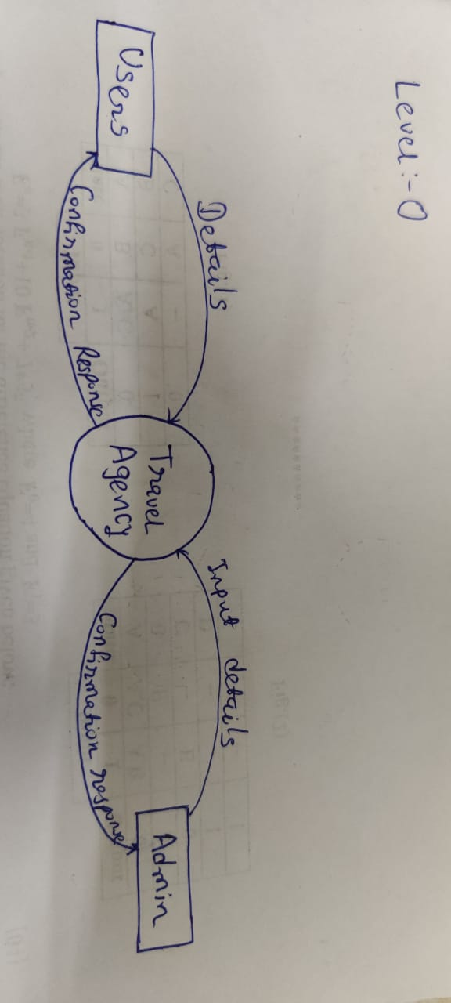

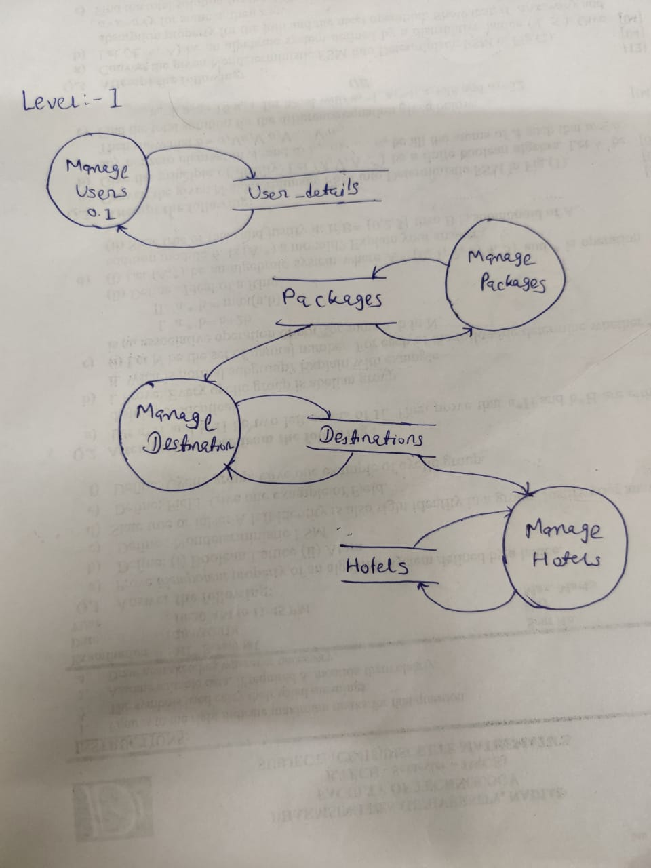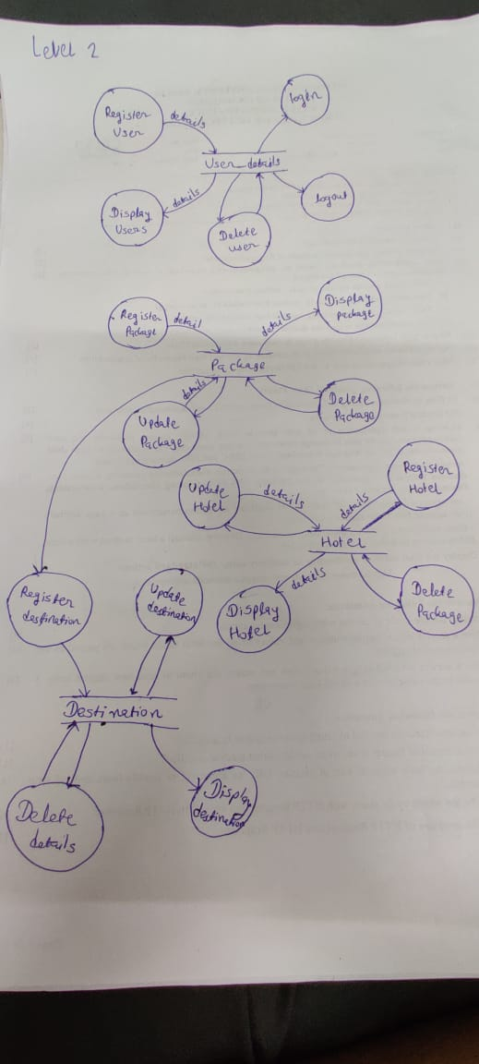

**4.6 E-R Diagram**

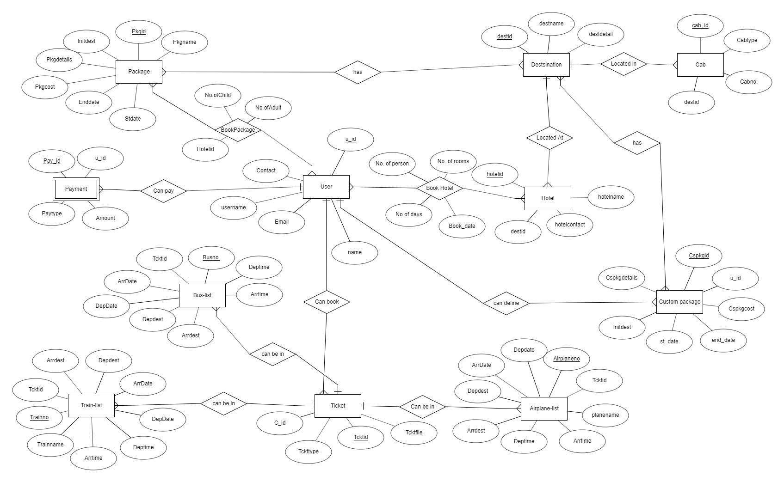

**4.7 Data Dictionary**

| **1.User** | | | | | | | | |
| --- | --- | --- | --- | --- | --- | --- | --- | --- |
| Sr. No. | Field Name | Data Type | Width | Required | Unique | PK/FK | Referenced table | Description |
| 1. | _id | Varchar | 10 | Yes | Yes | PK |  | Auto increment key generated by database itself |
| 2. | uname | Varchar | 10 | Yes | Yes |  |  | Unique id defined by user to login |
| 3. | password | Varchar | 8 | yes | no |  |  |  |
| 4. | name | Varchar | 50 | Yes | No |  |  |  |
| 5. | uemail | Varchar | 30 | Yes | Yes |  |  |  |

| **2.Package** | | | | | | | | |
| --- | --- | --- | --- | --- | --- | --- | --- | --- |
| Sr. No. | Field Name | Data Type | Width | Required | Unique | PK/FK | Referenced table | Description |
| 1. | Pkgid | Varchar | 10 | Yes | Yes | PK |  |  |
| 2. | Pkgname | Varchar | 20 | Yes | No |  |  |  |
| 3. | Pkgcost | Number | 8 | Yes | No |  |  |  |
| 4. | No Of Days | Number |  | Yes | No |  |  |  |
| 5. | Initdest | Varchar | 20 | Yes | No |  |  |  |
| 6. | Pkgdetail | Varchar | 100 | No | No |  |  |  |

| **3.Destination** | | | | | | | | |
| --- | --- | --- | --- | --- | --- | --- | --- | --- |
| Sr. No. | Field Name | Data Type | Width | Required | Unique | PK/FK | Referenced table | Description |
| 1. | Destid | Varchar | 10 | Yes | Yes | PK |  |  |
| 2. | Destname | Varchar | 20 | Yes | No |  |  |  |
| 3. | Destdetail | Varchar | 100 | No | No |  |  |  |
| 4. | Pkgid | Varchar | 20 | Yes | No |  |  |  |

| **4.Hotel** | | | | | | | | |
| --- | --- | --- | --- | --- | --- | --- | --- | --- |
| Sr. No. | Field Name | Data Type | Width | Required | Unique | PK/FK | Referenced table | Description |
| 1. | Hotelid | Varchar | 10 | Yes | Yes | PK |  |  |
| 2. | Hotelnm | Varchar | 30 | Yes | No |  |  |  |
| 3. | Hcost | Number | 10 | Yes | No |  |  |  |
| 4. | Destid | Varchar | 10 | Yes | No | FK | Destination |  |

| **5.BookPackage** | | | | | | | | |
| --- | --- | --- | --- | --- | --- | --- | --- | --- |
| Sr. No. | Field Name | Data Type | Width | Required | Unique | PK/FK | Referenced table | Description |
| 1. | Pkgid | Varchar | 10 | Yes | Yes | FK | Package |  |
| 2. | c_id | Varchar | 10 | Yes | Yes | FK | Customer |  |
| 4. | No of person | Number | 5 | Yes | No |  |  | Defines number of person are in the booked package. |
| **Primary key(Pkgid,c_id)** | | | | | | | | |

| **6.Airplane-list** | | | | | | | | |
| --- | --- | --- | --- | --- | --- | --- | --- | --- |
| Sr. No. | Field Name | Data Type | Width | Required | Unique | PK/FK | Referenced table | Description |
| 1. | Planeno. | Varchar | 10 | Yes | Yes | PK |  |  |
| 2. | PName | Varchar | 20 | Yes | No |  |  |  |
| 3. | Depdate | Date |  | Yes | No |  |  |  |
| 4. | Arrdate | Date |  | Yes | No |  |  |  |
| 5. | Deptime | Varchar | 20 | Yes | No |  |  |  |
| 6. | Arrtime | Varchar | 20 | Yes | No |  |  |  |
| 7. | Depplace | Varchar | 20 | Yes | No |  |  |  |
| 8. | Arrplace | Varchar | 20. | Yes | No |  |  |  |
| 9. | Tcktid | Varchar | 10 | Yes | No | FK | Ticket |  |

| **7.Train-list** | | | | | | | | |
| --- | --- | --- | --- | --- | --- | --- | --- | --- |
| Sr. No. | Field Name | Data Type | Width | Required | Unique | PK/FK | Referenced table | Description |
| 1. | Trainno. | Varchar | 10 | Yes | Yes | PK |  |  |
| 2. | TrName | Varchar | 20 | Yes | No |  |  |  |
| 3. | Depdate | Date |  | Yes | No |  |  |  |
| 4. | Arrdate | Date |  | Yes | No |  |  |  |
| 5. | Deptime | Varchar | 20 | Yes | No |  |  |  |
| 6. | Arrtime | Varchar | 20 | Yes | No |  |  |  |
| 7. | Depplace | Varchar | 20 | Yes | No |  |  |  |
| 8. | Arrplace | Varchar | 20. | Yes | No |  |  |  |
| 9. | Tcktid | Varchar | 10 | Yes | No | FK | Ticket |  |

| **8.Bus-list** | | | | | | | | |
| --- | --- | --- | --- | --- | --- | --- | --- | --- |
| Sr. No. | Field Name | Data Type | Width | Required | Unique | PK/FK | Referenced table | Description |
| 1. | Busno. | Varchar | 10 | Yes | Yes | PK |  |  |
| 2. | BusName | Varchar | 20 | Yes | No |  |  |  |
| 3. | Depdate | Date |  | Yes | No |  |  |  |
| 4. | Arrdate | Date |  | Yes | No |  |  |  |
| 5. | Deptime | Varchar | 20 | Yes | No |  |  |  |
| 6. | Arrtime | Varchar | 20 | Yes | No |  |  |  |
| 7. | Depplace | Varchar | 20 | Yes | No |  |  |  |
| 8. | Arrplace | Varchar | 20. | Yes | No |  |  |  |
| 9. | Tcktid | Varchar | 10 | Yes | No | FK | Ticket |  |

| **9.Ticket** | | | | | | | | |
| --- | --- | --- | --- | --- | --- | --- | --- | --- |
| Sr. No. | Field Name | Data Type | Width | Required | Unique | PK/FK | Referenced table | Description |
| 1. | Tcktid | Varchar | 10 | Yes | Yes | PK |  |  |
| 2. | c_id | Varchar | 10 | Yes | No | FK | Customer |  |
| 3. | Tckttype | Varchar | 10 | Yes | No |  |  |  |
| 4. | Tcktfile | Varchar | 30 | Yes | No |  |  |  |
|  |  |  |  |  |  |  |  |  |

| **10.Cab** | | | | | | | | |
| --- | --- | --- | --- | --- | --- | --- | --- | --- |
| Sr. No. | Field Name | Data Type | Width | Required | Unique | PK/FK | Referenced table | Description |
| 1. | Cabid | Varchar | 10 | Yes | Yes | PK |  |  |
| 2. | Cabtype | Varchar | 20 | Yes | No |  |  |  |
| 3. | Cabno | Varchar | 20 | Yes | Yes |  |  |  |
| 4. | Destid | Varchar | 10 | Yes | No | FK | Destination |  |

| **11.Book-hotel** | | | | | | | | |
| --- | --- | --- | --- | --- | --- | --- | --- | --- |
| Sr. No. | Field Name | Data Type | Width | Required | Unique | PK/FK | Referenced table | Description |
| 1. | Hbookid | Varchar | 10 | Yes | Yes | PK |  |  |
| 2. | Hotelid | Varchar | 10 | Yes | Yes | FK | Hotel |  |
| 3. | Pkgid | Varchar | 10 | No | No | FK | Package |  |
| 4. | Cspkgid | Varchar | 10 | No | No | FK | Self-Package |  |
| 4. | c_id | Varchar | 10 | Yes | No | FK | Customer |  |
| 5. | book_date | Date |  | Yes | No |  |  |  |
| 6. | No. of rooms | Number | 3 | Yes | No |  |  |  |
| 7. | No. of days | Number | 3 | Yes | No |  |  |  |
| 8. | Persons | Number | 3 | Yes | No |  |  |  |

| **12.Custom package** | | | | | | | | |
| --- | --- | --- | --- | --- | --- | --- | --- | --- |
| If a customer needs to define his own package then he can add a package, too. This table is for the packages defined by customers. | | | | | | | | |
| Sr. No. | Field Name | Data Type | Width | Required | Unique | PK/FK | Referenced table | Description |
| 1. | CsPkgid | Varchar | 10 | Yes | Yes | PK |  |  |
| 2. | C_id | Varchar | 10 | Yes | No | FK | Customer |  |
| 3. | CsPkgcost | Number | 8 | Yes | No |  |  |  |
| 4. | Stdate | Date |  | Yes | No |  |  |  |
| 5. | Enddate | Date |  | Yes | No |  |  |  |
| 6. | Initdest | Varchar | 20 | Yes | No |  |  |  |
| 7. | CsPkgdetail | Varchar | 100 | No | No |  |  |  |

|  |  |  |  |  |  |  |  |  |
| --- | --- | --- | --- | --- | --- | --- | --- | --- |
| **13.cspackage-place** | | | | | | | | |
| Sr. No. | **Field Name** | **Data Type** | Width | Required | Unique | PK/FK | **Referenced table** | Description |
| 1. | CsPkgid | Varchar | 10 | Yes | No | FK | Custom Package |  |
| 2. | Destid | Varchar | 10 | Yes | No | FK | Destination |  |
| **Primary key(CsPkgid,Destid)** | | | | | | | | |

|  |  |  |  |  |  |  |  |  |
| --- | --- | --- | --- | --- | --- | --- | --- | --- |
| **14.payment** | | | | | | | | |
| Sr. No. | **Field Name** | **Data Type** | **Width** | **Required** | Unique | PK/FK | **Referenced table** | Description |
| **1.** | **Pay_id** | **Varchar** | **10** | **Yes** | **Yes** | **PK** |  |  |
| **2.** | **u_id** | **Varchar** | **10** | **Yes** | **Yes** | **FK** | **User** |  |
| **3.** | **Amount** | **Number** | **8** | **Yes** | **No** |  |  |  |
| **4.** | **Paytype** | **Varchar** | **10** | **Yes** | **No** |  |  |  |

5. Implementation Details

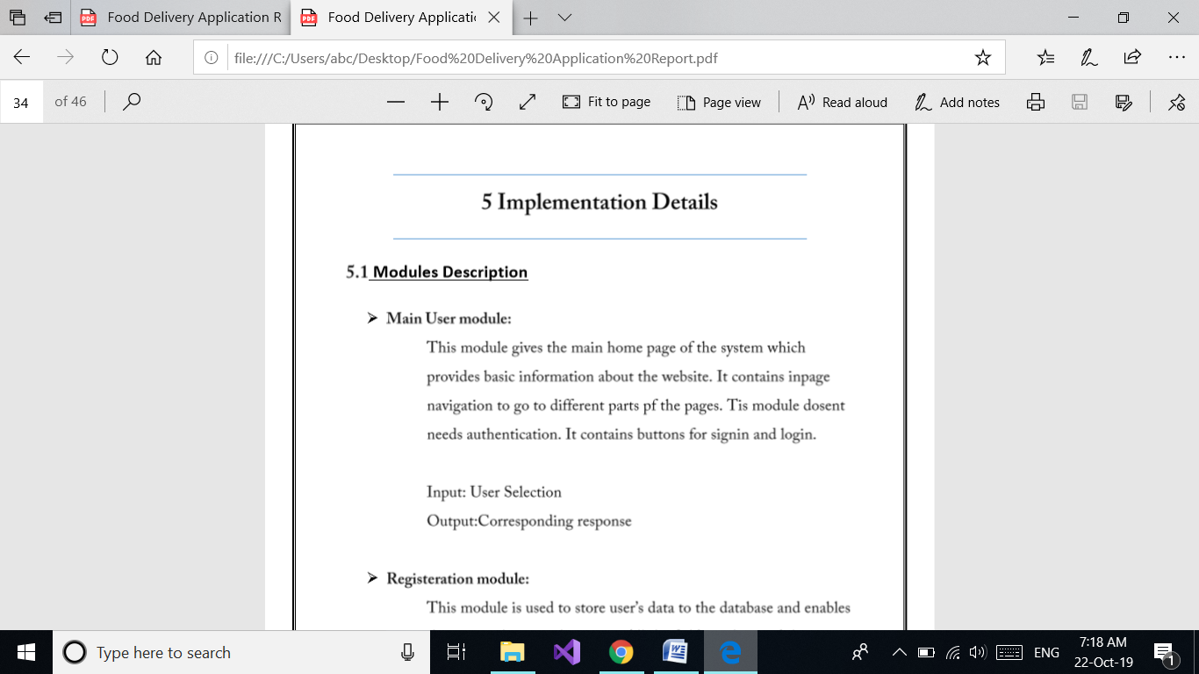

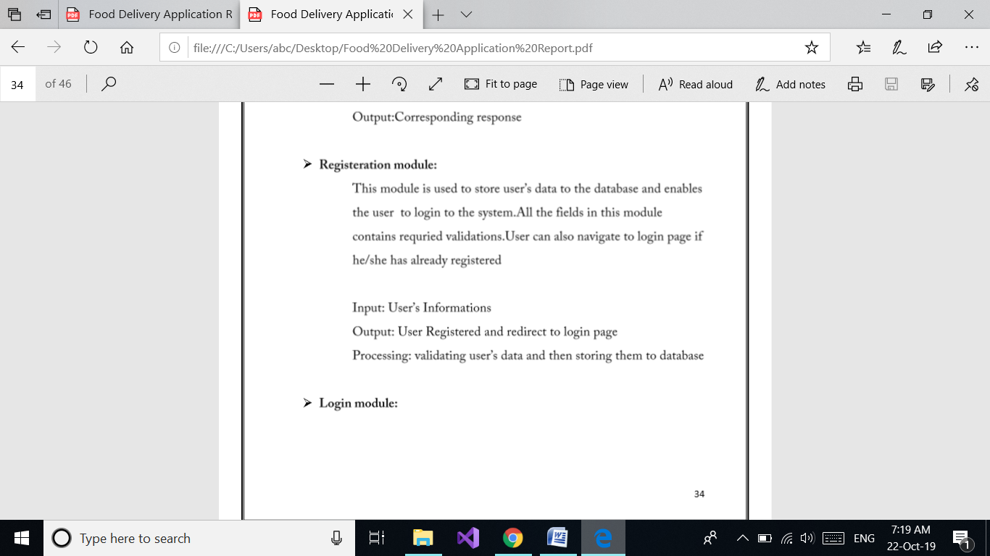

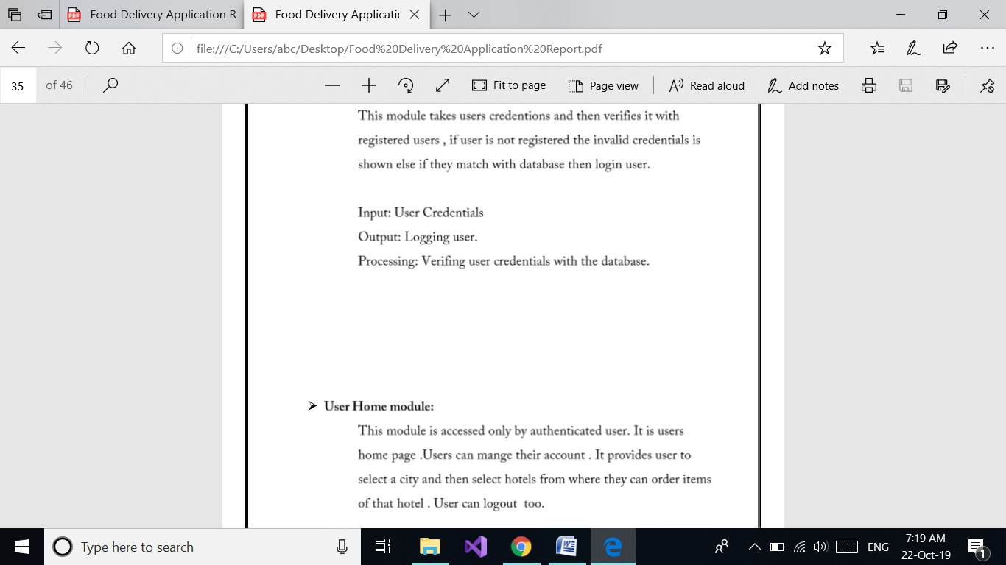



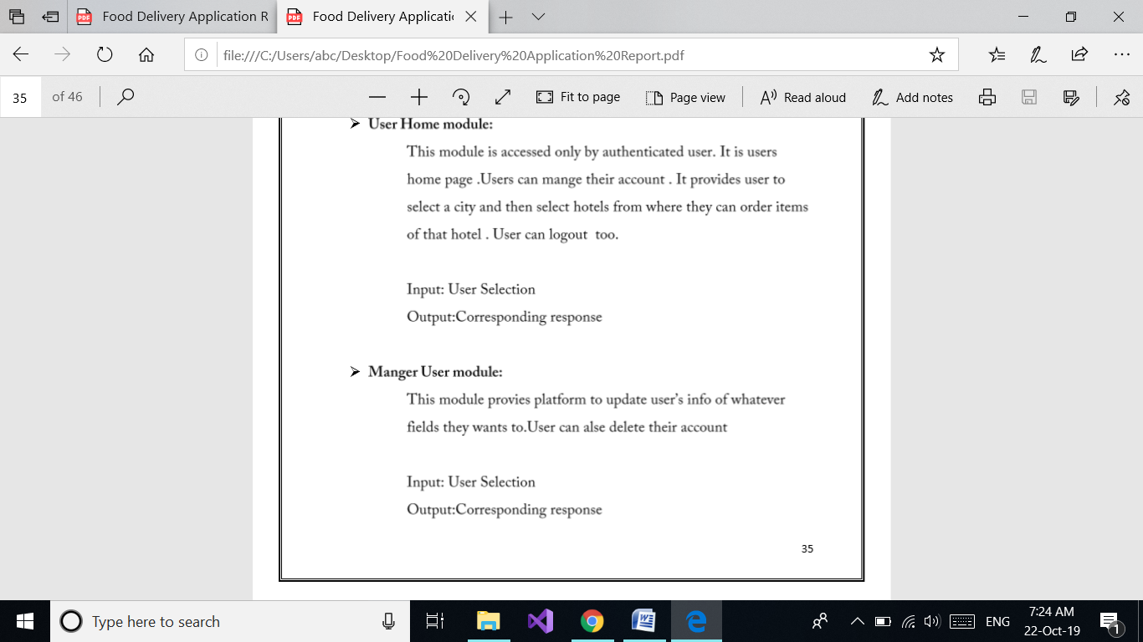

**5.2 Function prototypes**

Login

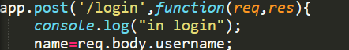

Delete Package



Register



View package



Book Package



View destination by package



Update package



6. Testing

7. screen shots

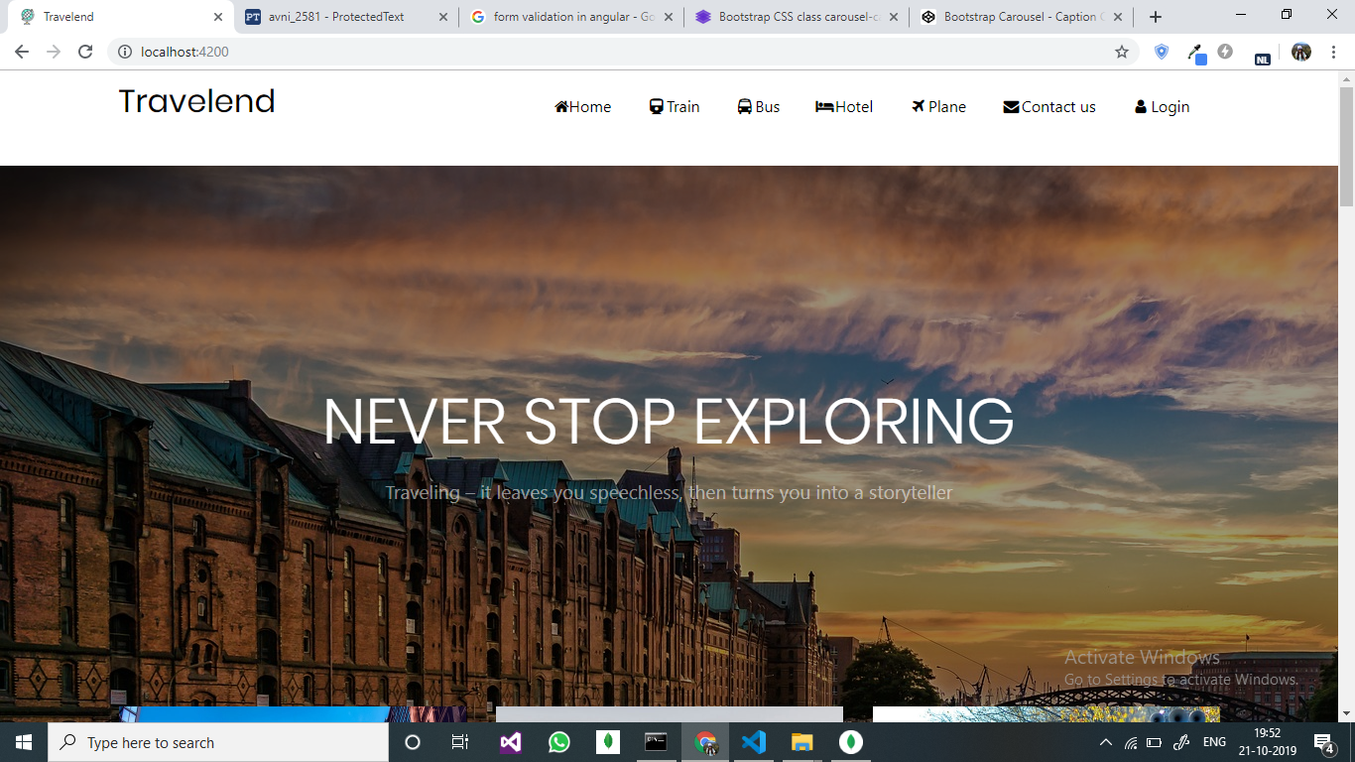

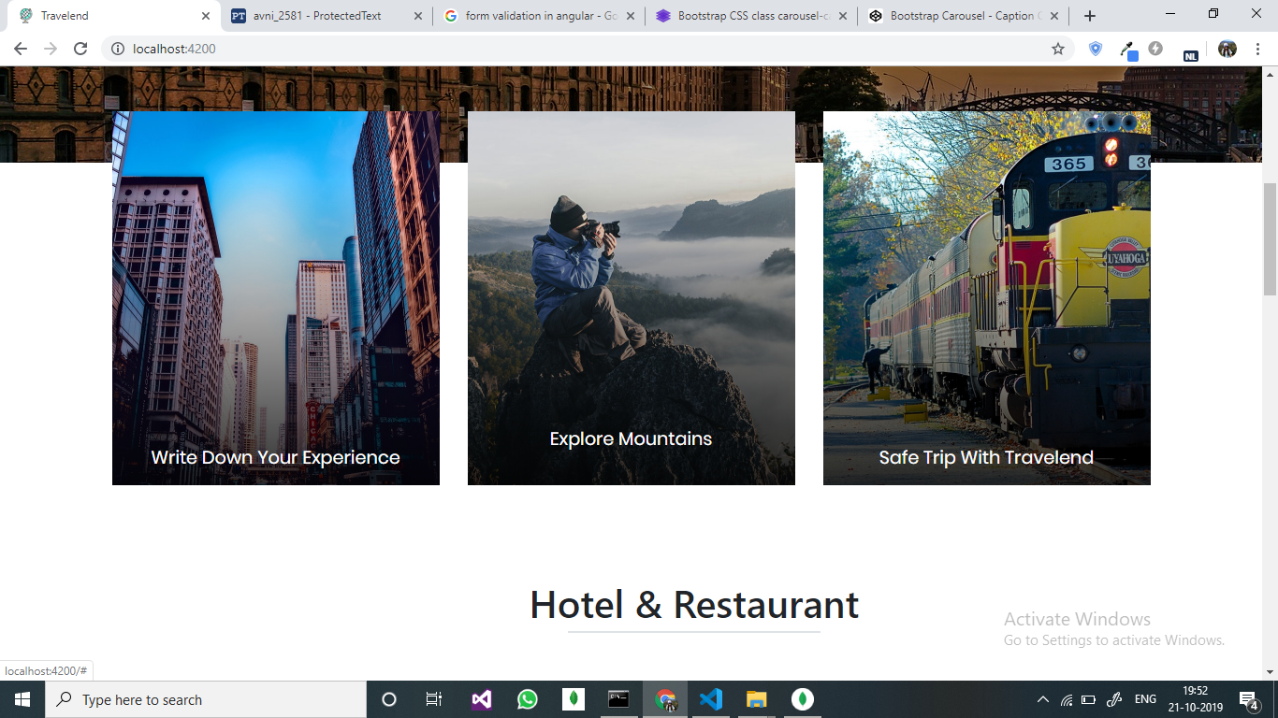

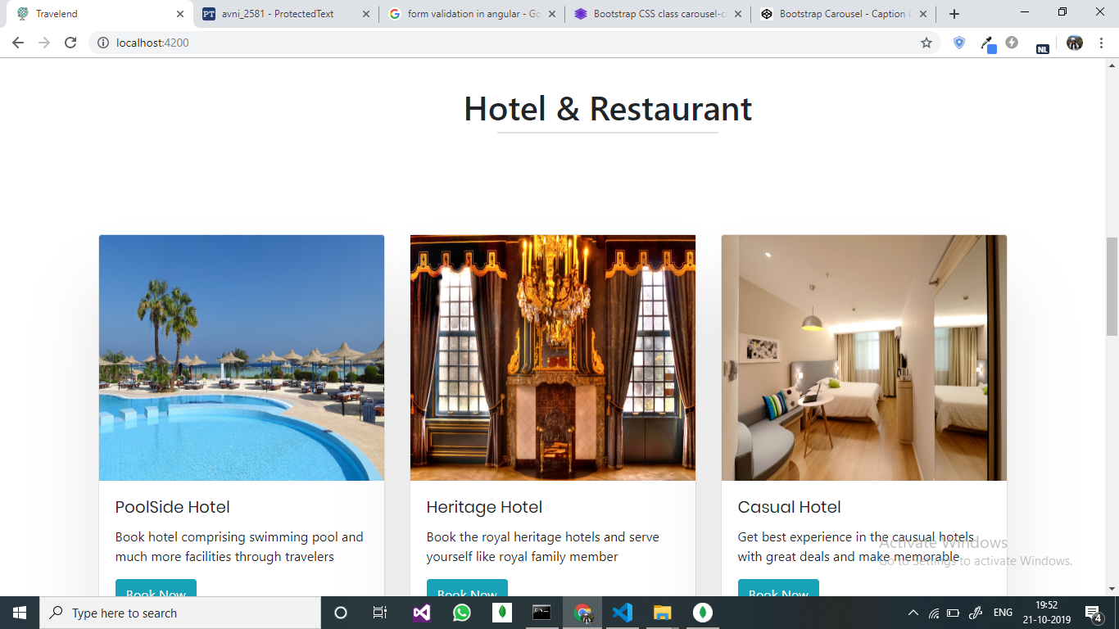

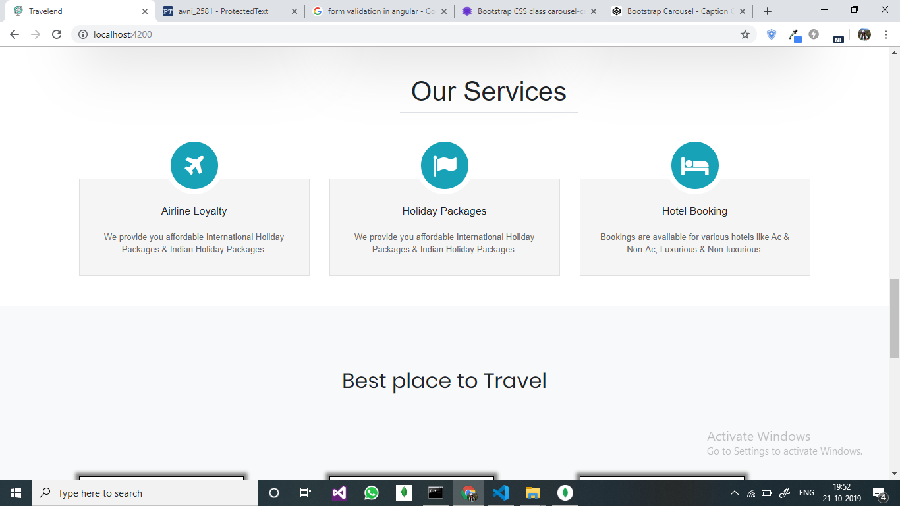

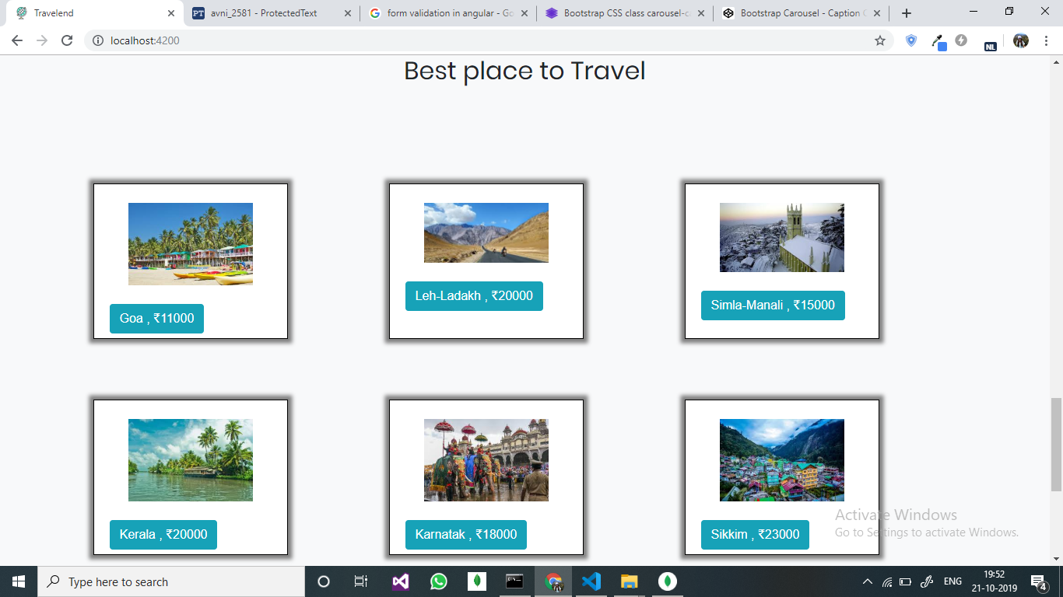

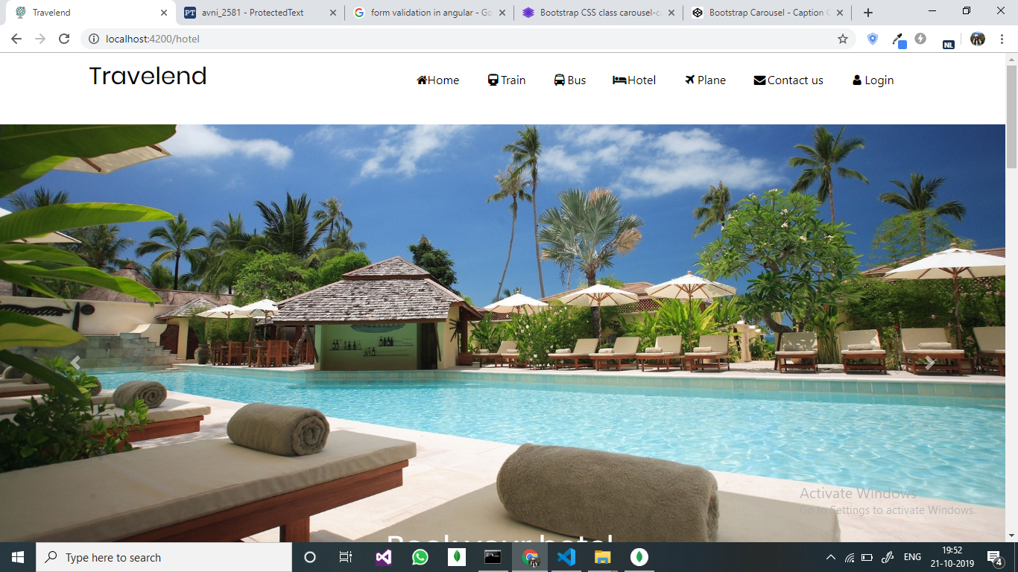

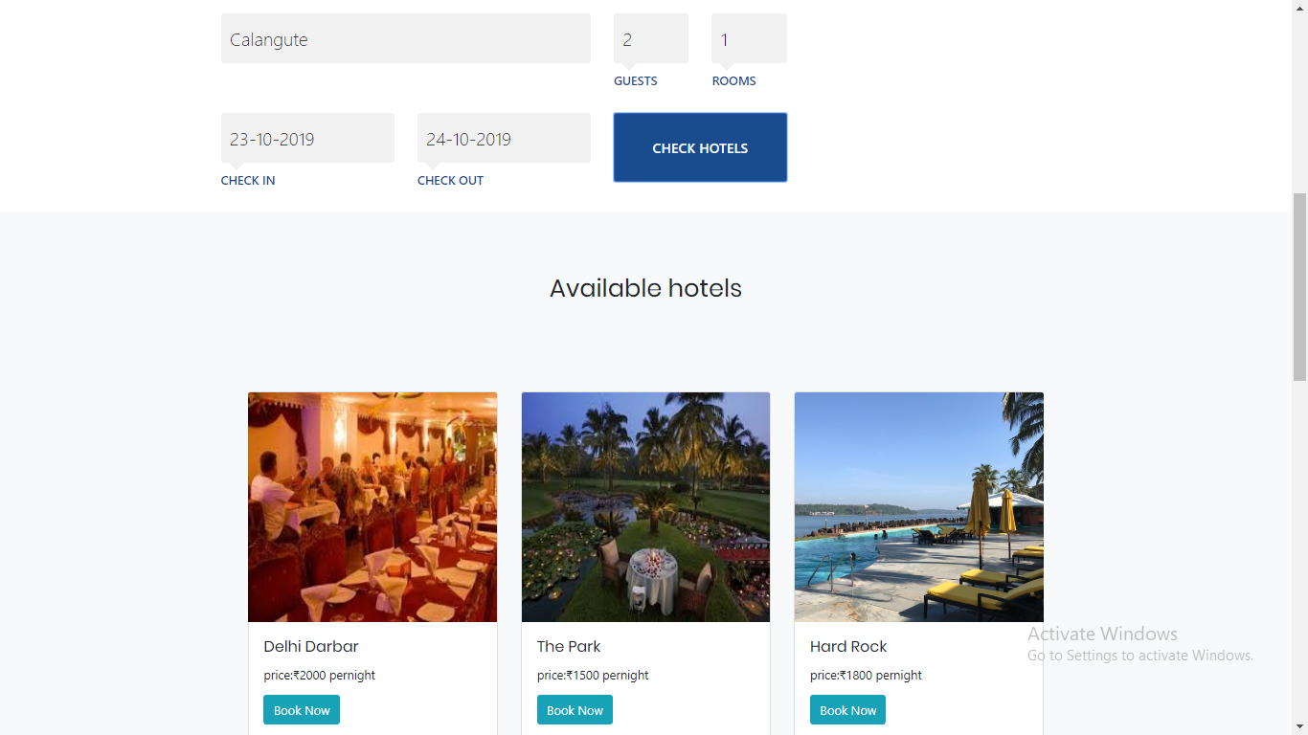

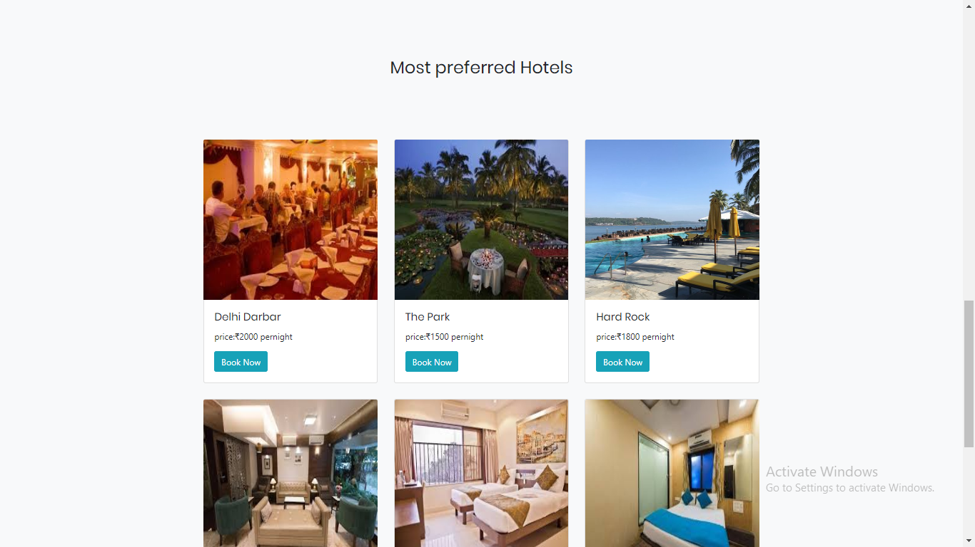

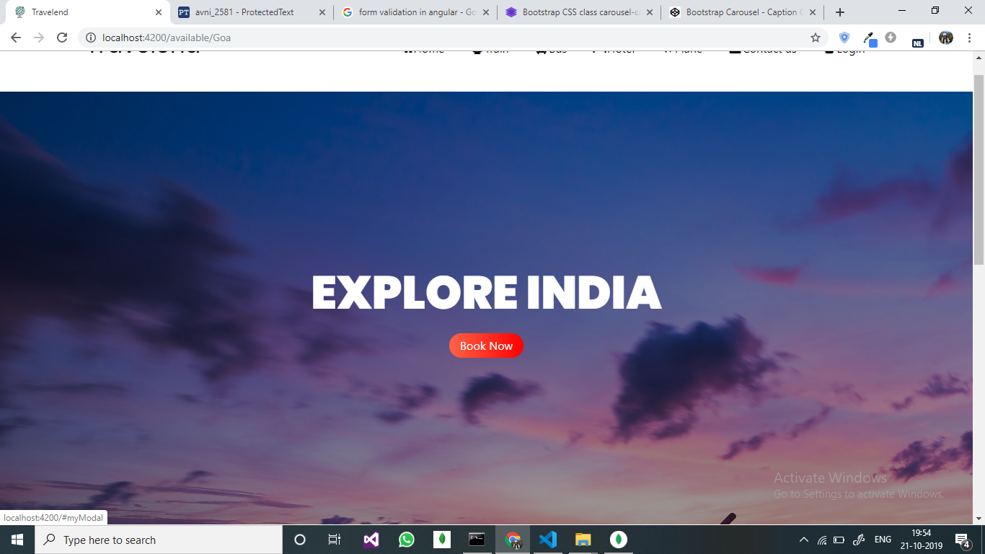

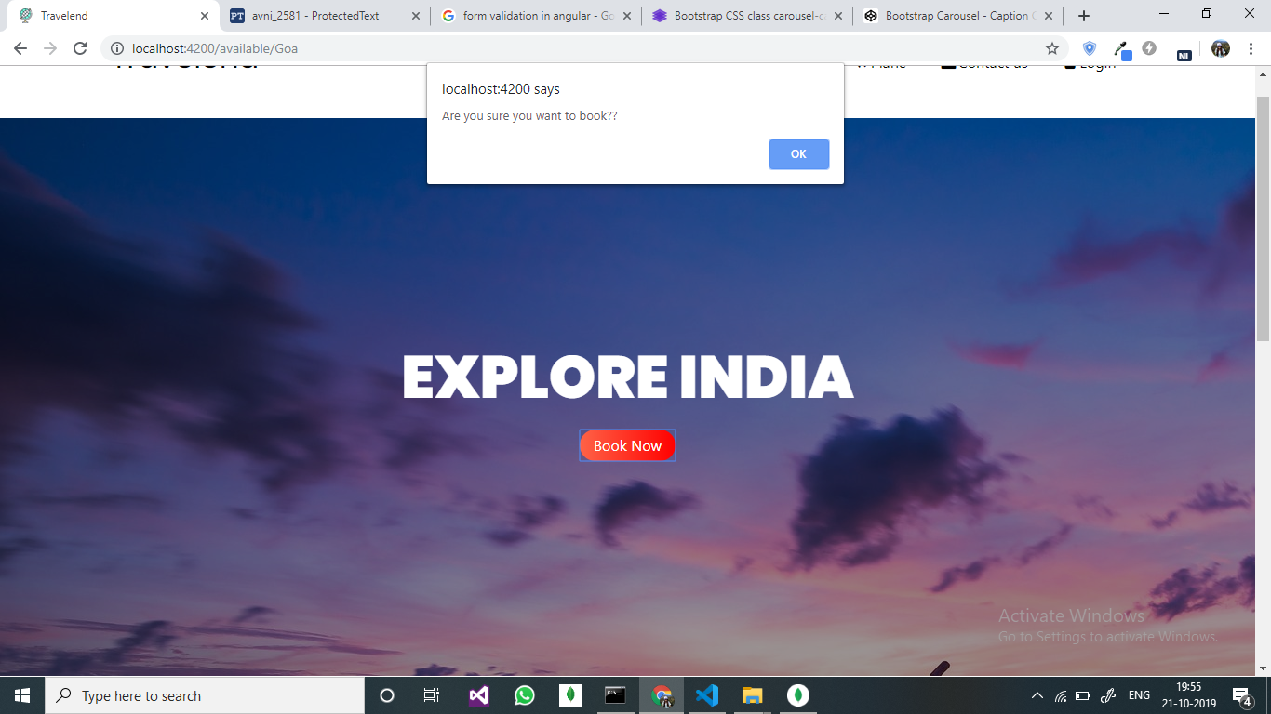

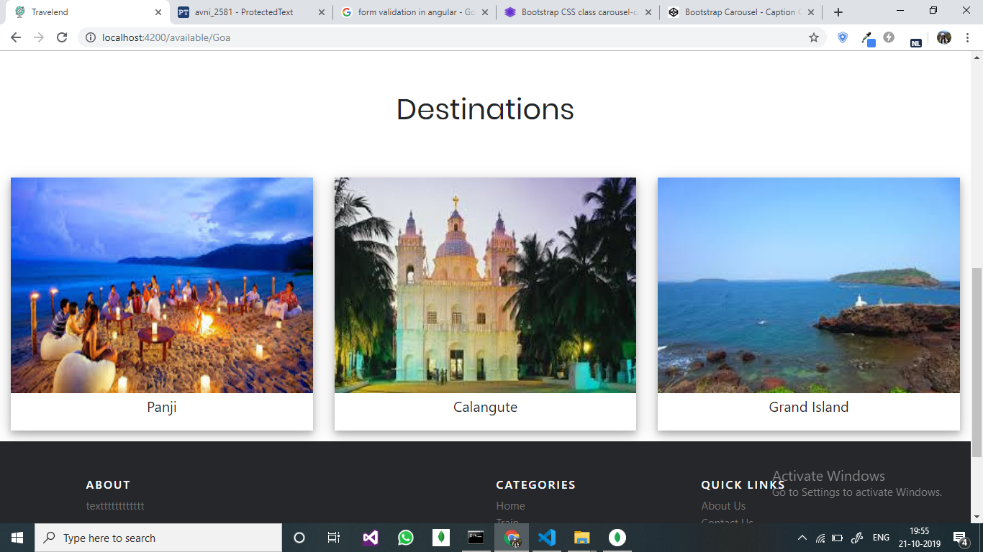

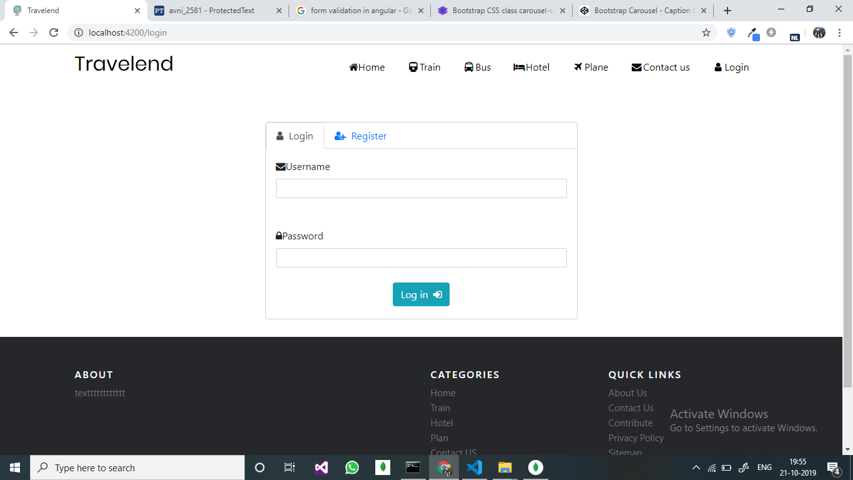

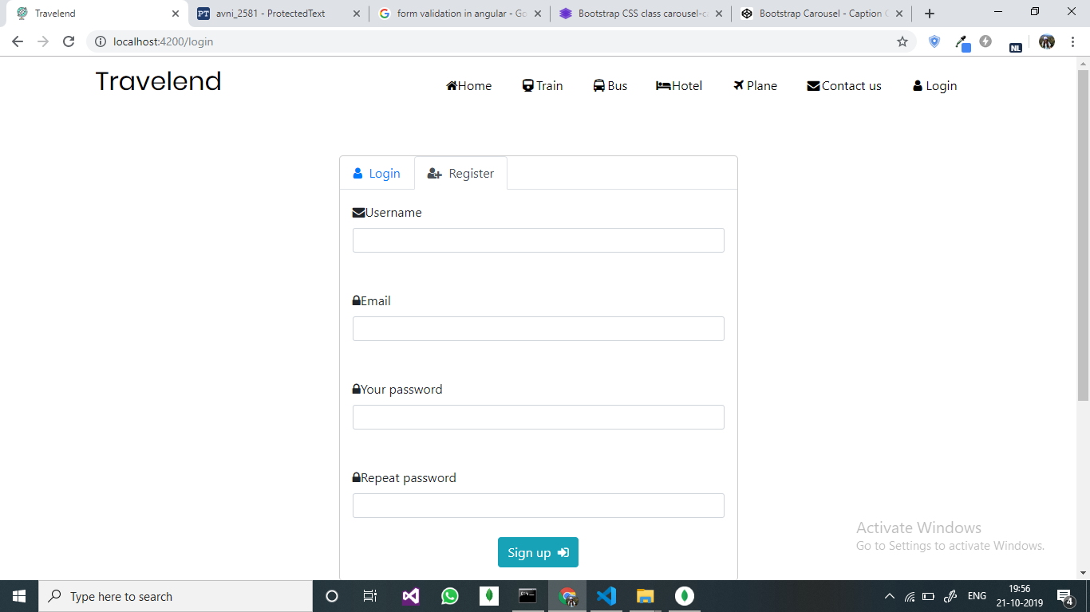

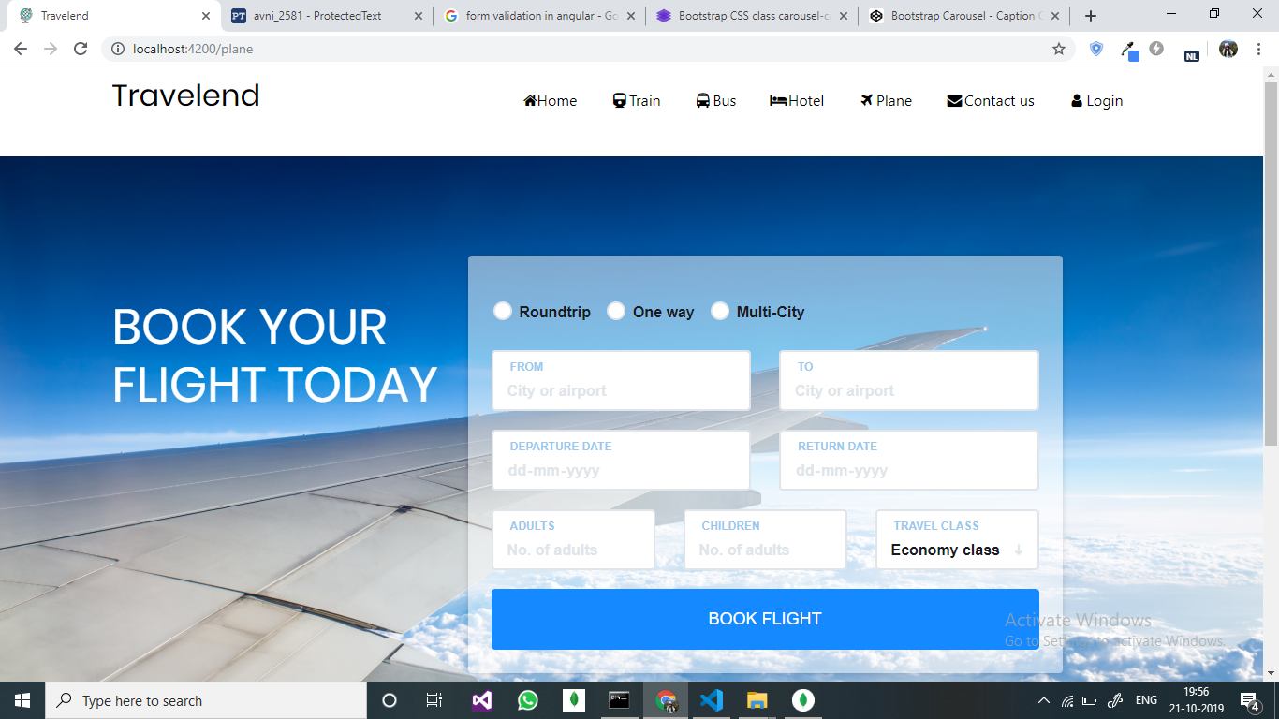

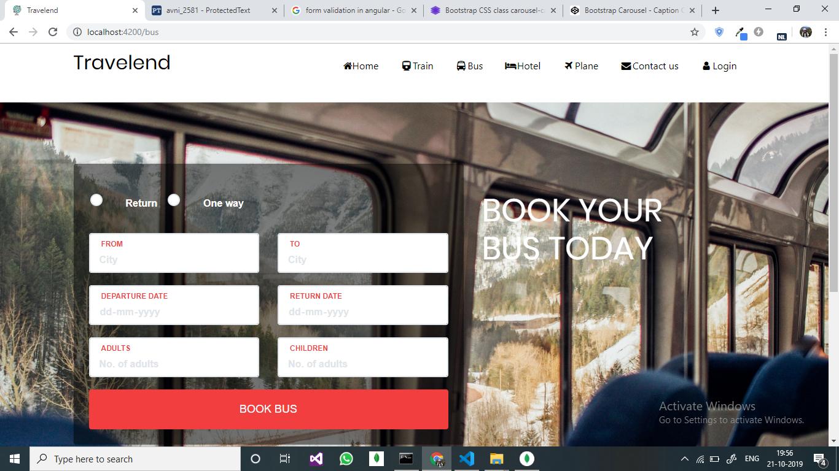

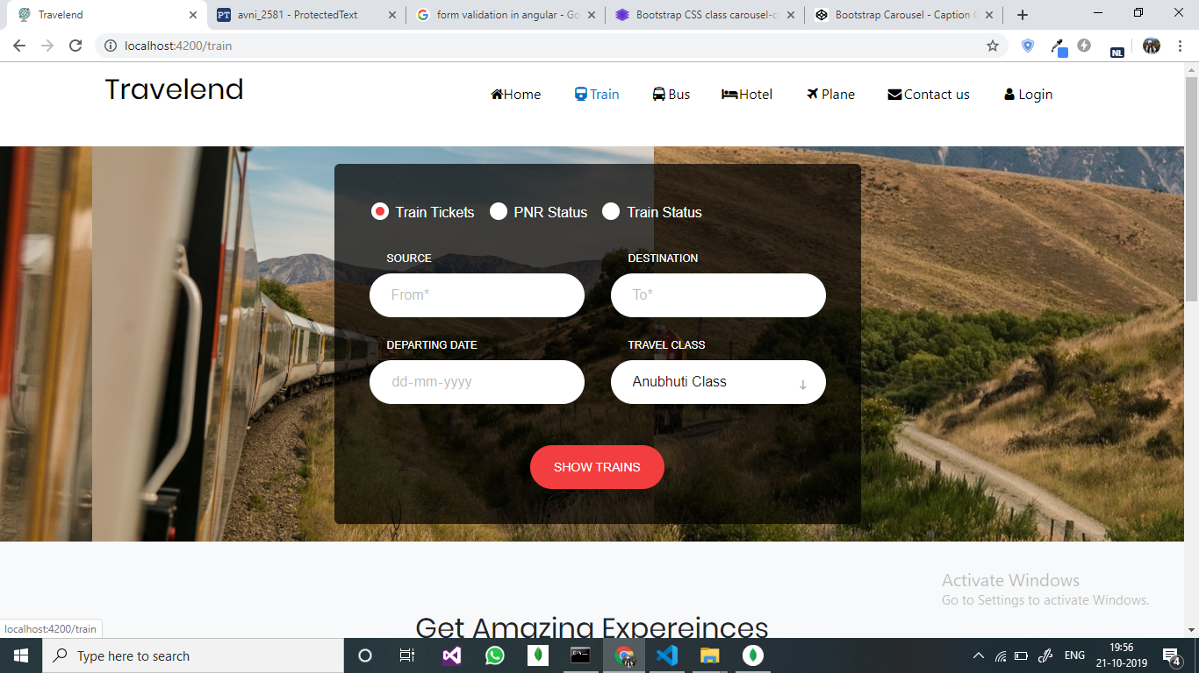

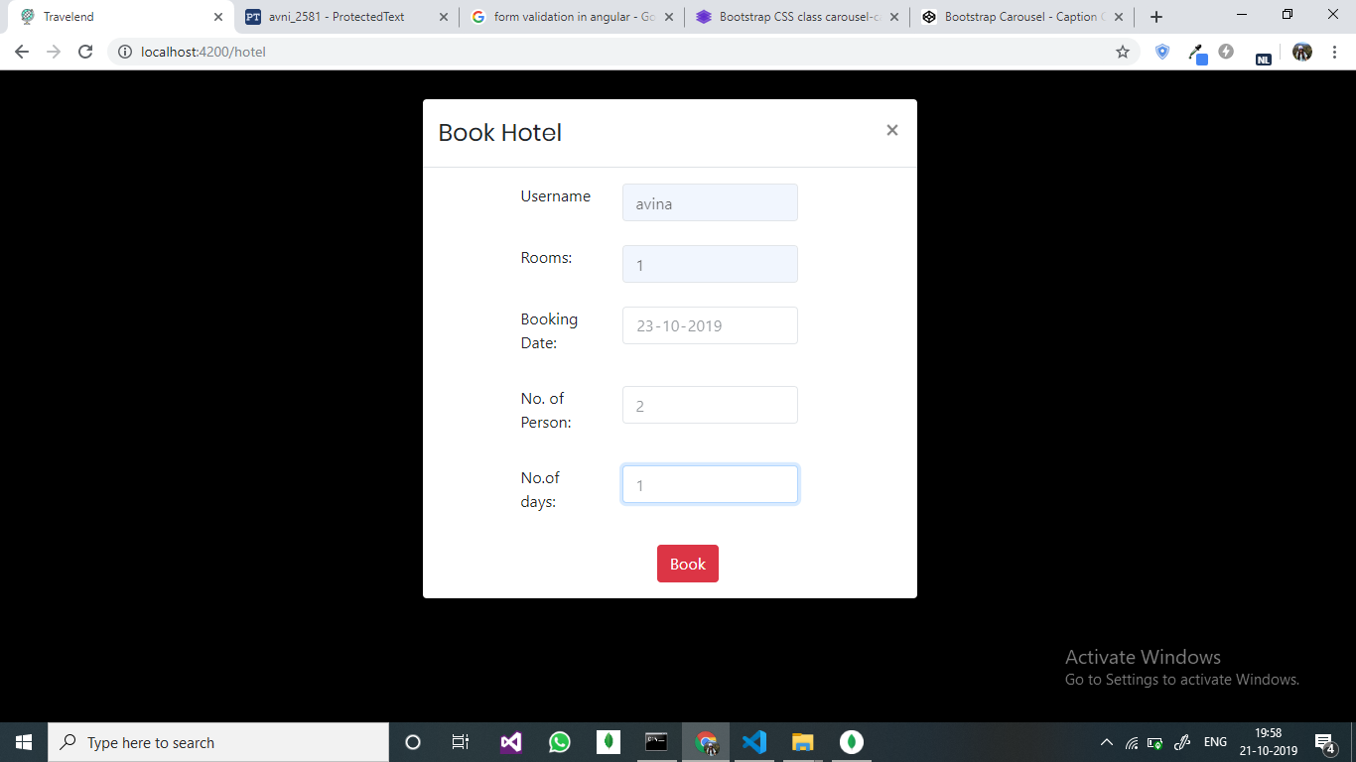

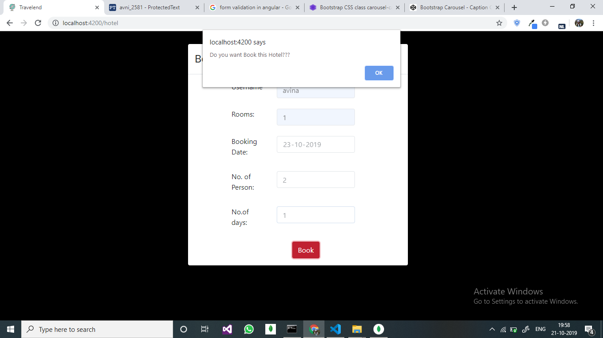

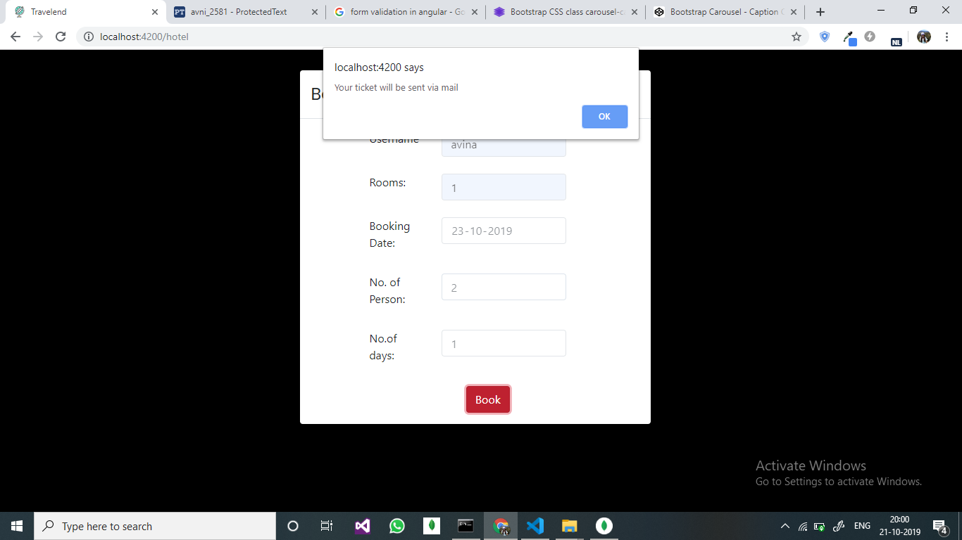

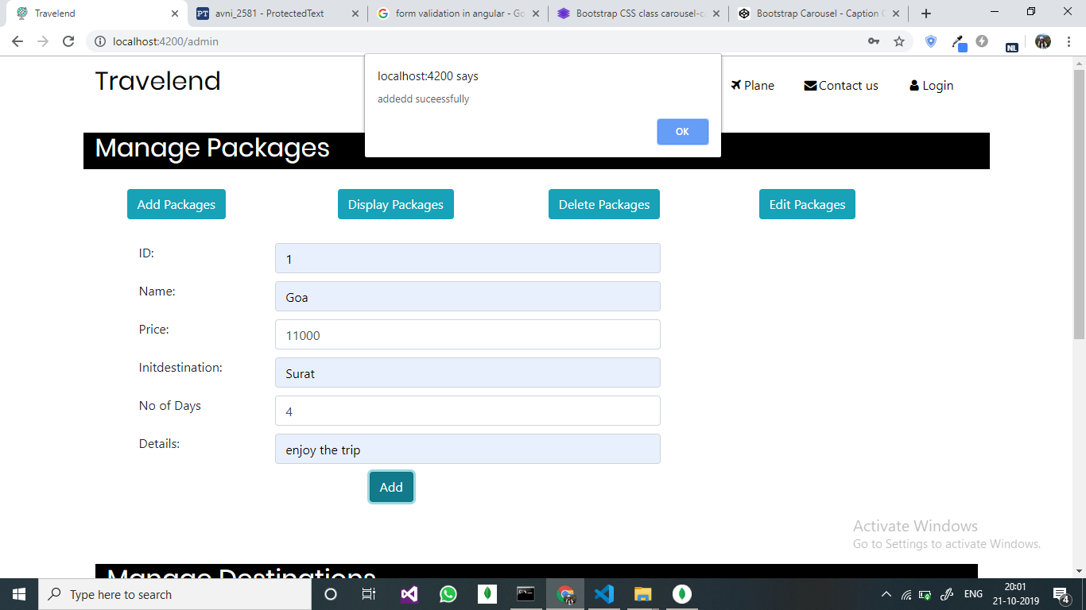

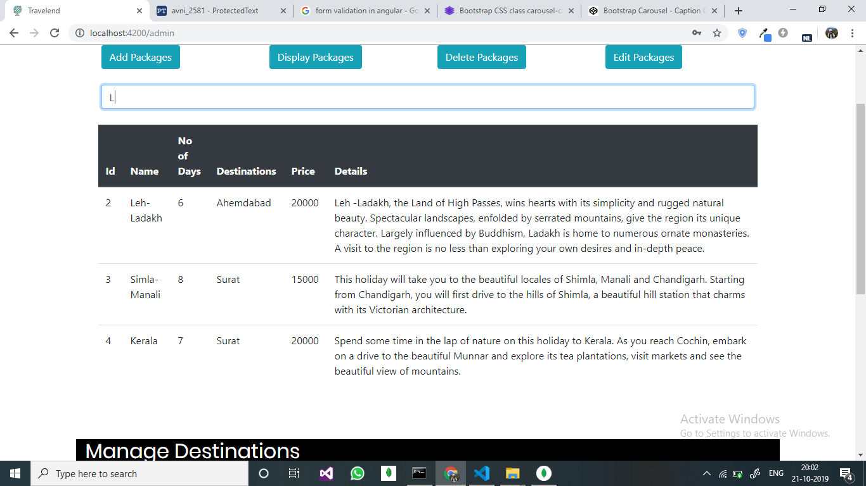

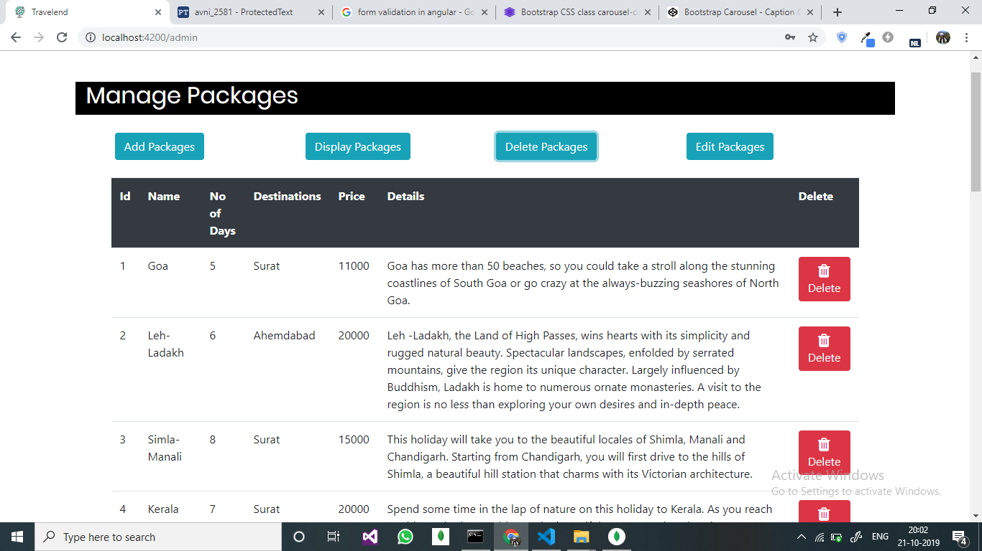

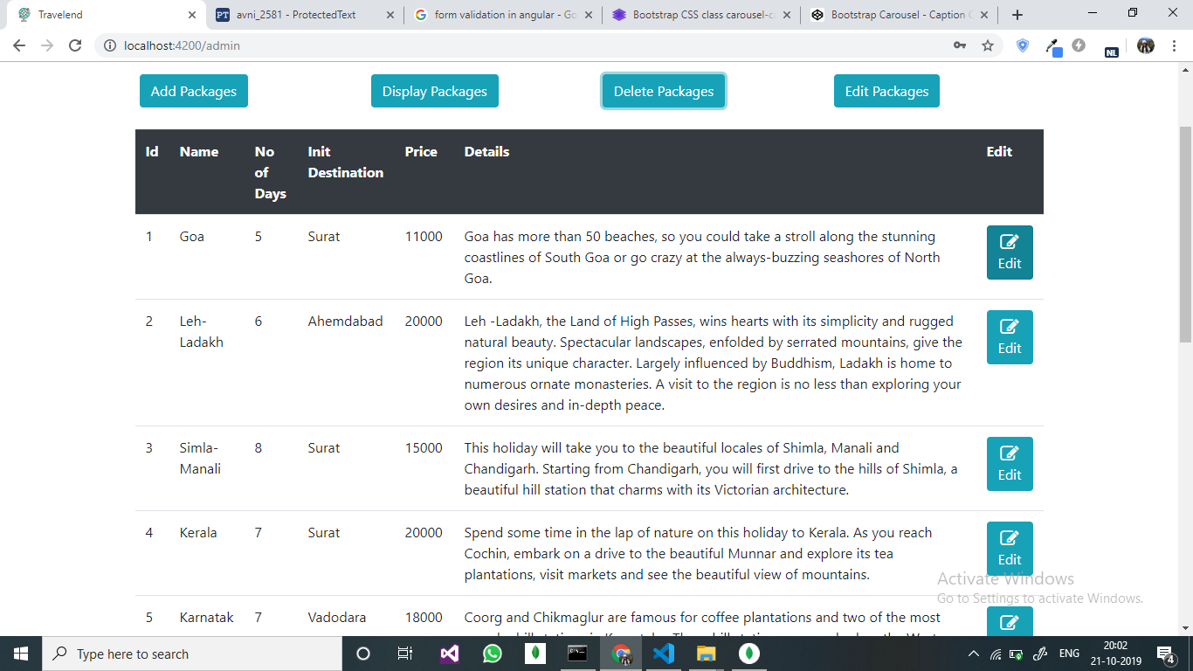

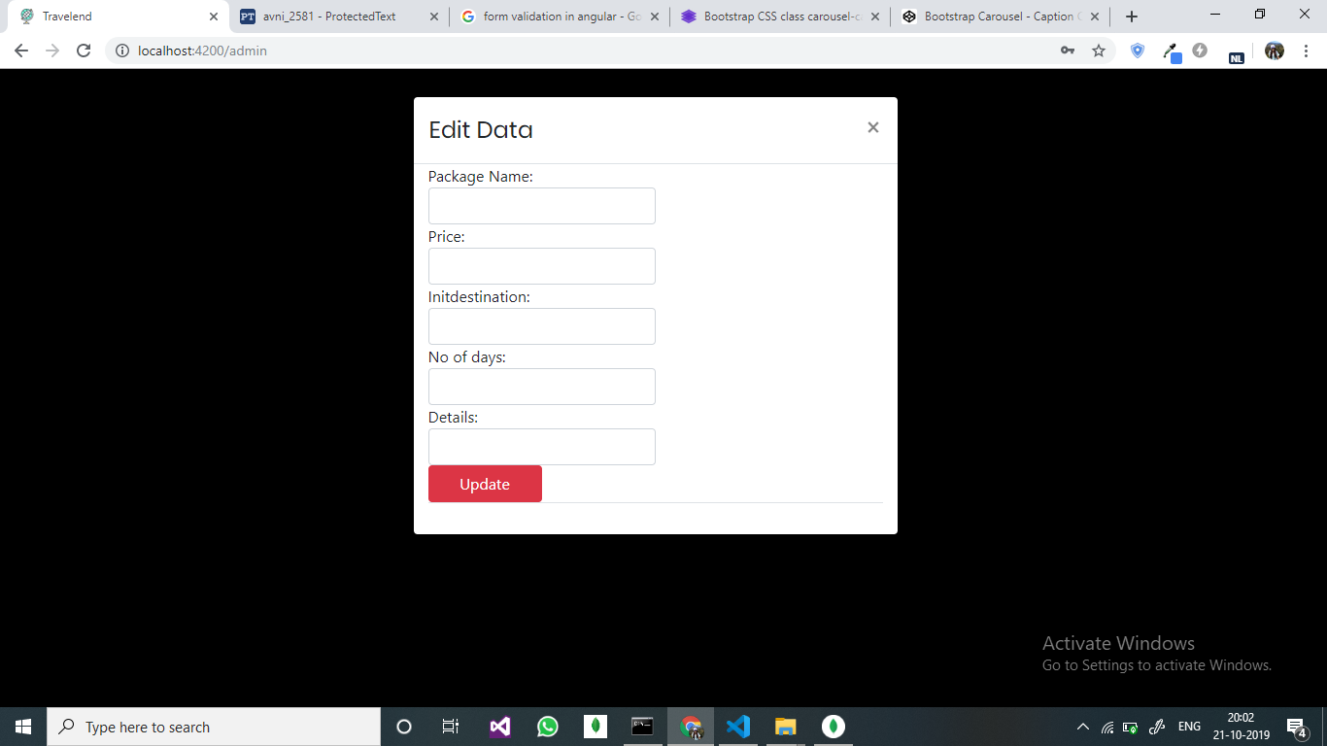

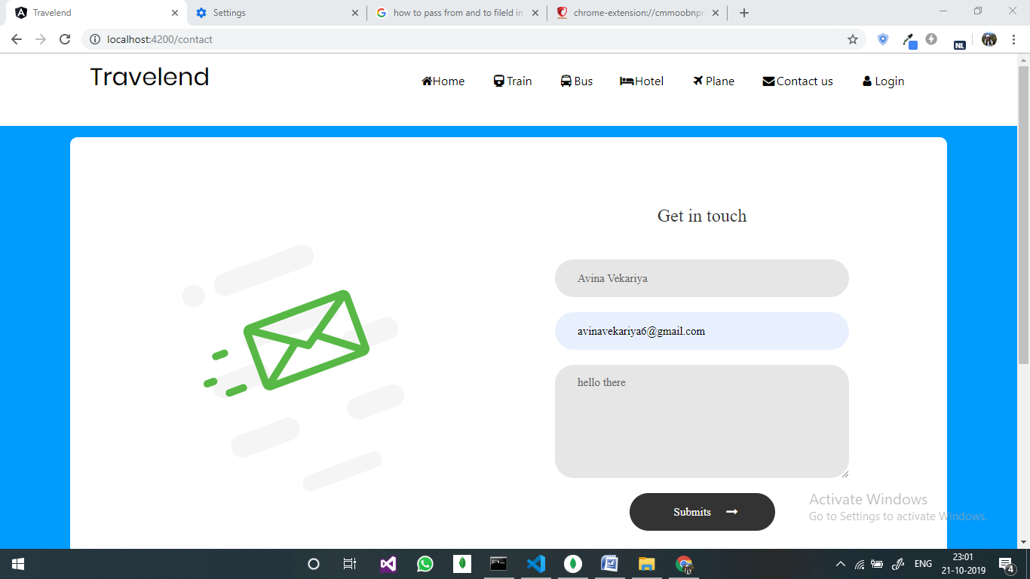

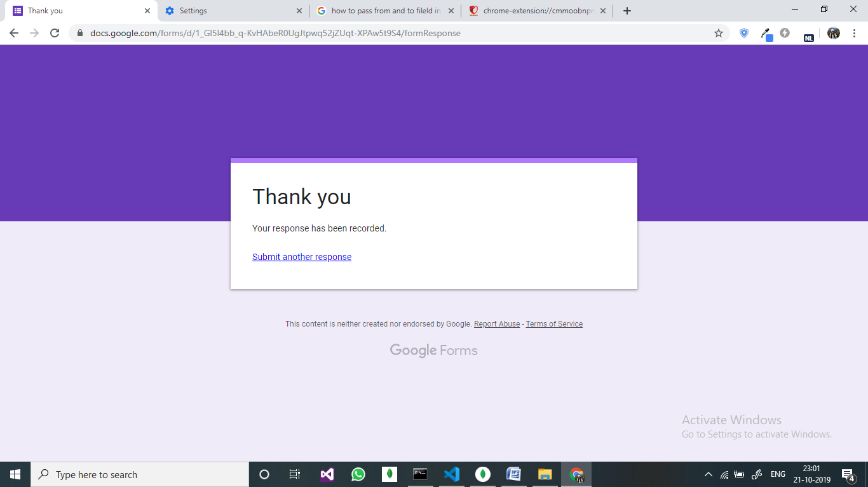

8. conclusion

The functionalities implemented in system after understanding all the system modules according to the requirements. Functionalities That are successfully implemented in the system are :

* User registration containing all the necessary validation on field
* mailing system
* login
* user authentication
* logout
* hotel searching according to city
* view train and buses according to your search
* view destination of packages
* book packages
* user authentication
* Book tickets
* Admin side management
* Dynamic content on pages from database

After the implementation and coding of system comprehensive testing was performed on the system to determine the errors and possible flaws in the system.

9. Limitations and Future Enhancements

The System has adequate scope for modification in future if it is necessary.

Development and launching of Mobile app and refining existing services and adding more service, System security, data security and reliability are the main feature.

The API for the booking and payment gateway can be added.

In the existing system there are only some selected cities, so if user wants to explore some specific site with adding new cities across the country so as an extension to the site we can add more cities as compared to existing site.

10. Reference / Bibliography

Following links and websites were referred during the development of this project.

<https://www.google.co.in>

<http://www.wikipedia.org>

<http://www.getbootstrap.com>

<http://www.goibibo.com>

<http://www.makemytrip.com>

<http://www.w3schools.com>

<http://www.tutorialspoint.com>

<http://www.angular.io>

<http://www.stackoverflow.com>